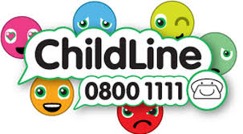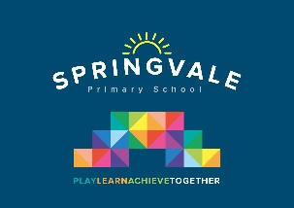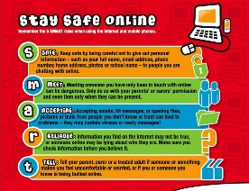

|  |  |
| --- | --- |
| **Learning Project WEEK 6- Food** | |
| **Age Range:** Nursery | |
| **Weekly Maths Tasks (Aim to do 1 per day)** | **Weekly Reading Tasks (Aim to do 1 per day)** |
| * Watch a Numberblocks clip each day at: [BBC](https://www.bbc.co.uk/iplayer/episodes/b08bzfnh/numberblocks?page=2) or [CBeebies](https://www.bbc.co.uk/cbeebies/shows/numberblocks). Use this guide [here](https://www.bbc.co.uk/cbeebies/joinin/numberblocks-help-your-child-with-maths) to give you ideas on what to do with your children whilst watching an episode. * Explore weighing and measuring food on the kitchen scales or if you have some old scales, in the garden with soil, stones or sand. Use the language heavy/light. If your child is struggling to understand these concepts, start with ‘heavy’, and collect things that are heavy and experience what it’s like to pick up something heavy. Then repeat the process with ‘light’. You can progress to talking about objects that are the *heaviest* or *lightest.* * Look for numerals on packaging you find around the house. Can your child recognise the numerals and count out a matching amount? | * Read a variety of books at home. Favourites can be repeated. Hearing the patterns of language in a story will support your child’s language development. * Make an object alphabet. Find an object that begins with every letter in the alphabet. If your child needs to concentrate on one sound at a time, use just one. Make ‘t’ soup, for example, and throw anything you can find into the pot that starts with t. * Look at recipe books and food magazines. Encourage your child to use their phonics knowledge to decode the ingredients list. Select a recipe and make this together. Encourage your child to look for initial sounds on packaging as a clue to which ingredient it is. |
| **Weekly Phonics Tasks (Aim to do 1 per day)** | **Weekly Writing Tasks (Aim to do 1 per day)** |
| * Sing Nursery Rhymes and songs together. Add in actions and change the words. Can children think of different rhyming words to add in? Repeat old favourites and learn new rhymes. You can find an A-Z of [Nursery Rhymes](https://allnurseryrhymes.com/). * Daily phonics - Practice the sounds your child is working on and blend words. This can be oral blending (e.g. spoken out loud c-a-t) or written if appropriate. [Interactive games](https://www.phonicsplay.co.uk/). * Pour flour, rice or lentils into a shallow tray or plate. Show your child a letter, digraph, trigraph or tricky word and ask them to ‘write it’ in the food using their finger. | * Practice name writing. Can they write their first name? Middle name? Surname? * Practice forming the letters of the alphabet. Follow your school’s script. * Using recipes from books as a guide, ask your child to create their own recipe for their dream meal. They could draw out the ingredients and label them and draw the finished meal. * Look at a range of different packages found around the kitchen. Discuss with your child, the features of the packet, writing, pictures, what its made of, shape. Support them to design a package for a treat of their choice. |
| **Learning Project - to be done throughout the week** | |
| **The project this week aims to provide opportunities for your child to learn more food. Learning may focus on where different foods originate from, what makes a healthy meal, opportunities to cook etc. Choose from the following;**   * **Healthy/ Unhealthy-**    + Provide your child with a selection of items from your kitchen cupboards. Can they sort them into things that are healthy and unhealthy? Discuss why the food is good for you or bad for you. Look at the [Eatwell plate](https://www.nhs.uk/live-well/eat-well/the-eatwell-guide/) to help figure out which foods they should eat a lot of or not very much of. * Discuss how exercise is an important part of staying healthy. Watch and complete a 10 minute [shake up.](https://www.nhs.uk/10-minute-shake-up/shake-ups) * **5 a day-**   + Support your child to create a food diary to record how many pieces of fruit and vegetables they eat in a day. They could write these using their phonics knowledge or draw a picture of each item. * **Create a collage-**   + Ask your child to draw out a number of fruits or vegetables, large enough to fill a piece of A4 paper. Provide them with a selection of colourful packaging. Can they cut out and collage on to their picture to * **Play shops-**   + Using toy food or old packaging, set up a food shop for your child to act out being the shopkeeper and customer. You could introduce coins to support their developing knowledge of money. Give them a notepad to use as a shopping list to encourage in the moment writing. * **Potato/ Vegetable Printing-**   + Using a selection of vegetables available in your kitchen, support your child to print and explore the shapes and patterns created:      * **Make cornflour gloop-**   + Mix cornflour with a small amount of water in a mixing bowl. It will make a slimy, stretchy mixture. Allow your child to explore the change of texture from wet to dry and the texture of the gloop. | |
| **Additional learning resources parents may wish to engage with** | |
| [**Twinkl**](https://www.twinkl.co.uk/offer/UKTWINKLHELPS?utm_source=promo&utm_medium=email&utm_campaign=England_coronavirus_schools_email&utm_content=offer_link) **-** to access these resources click on the link and sign up using your own email address and creating your own password. Use the offer code UKTWINKLHELPS. | |
| **#TheLearningProjects** | |